Drug and Alcohol Policy

1.0 Introduction

Modular500 Ltd is a responsible employer and takes its obligations to all employees very seriously. The Health and Safety at Work Act 1974 places a duty on employers to provide a safe and healthy working environment, and to ensure the health, safety and welfare at work of its employees as well as any visitors or contractors both on the premises, or on any of its construction sites.

2.0 Aims of the Policy

This policy aims to:
- Comply with the Company’s legal obligations to provide a safe and healthy working environment for all its staff
- Comply with all the requirements imposed by law
- Raise awareness of the dangers and penalties associated with the use of controlled drugs
- Protect employees from the dangers of alcohol abuse
- Guarantee the right of all staff to work in an environment unaffected using illegal drugs or alcohol abuse
- Provide support to staff whose lives are affected by drug or alcohol related issues.

3.0 Health and Safety

The use of illegal/controlled substances and misuse of alcohol not only affects an individual employee’s health and performance but impacts on those of their colleagues and puts everyone at risk.

Symptoms of misuse may include:
- Unusually high rates of absenteeism
- Unkempt appearance/lack of hygiene
- Irritability
- Mood fluctuations
- Spasmodic work patterns and lower productivity
- Poor relations with colleagues

Employees should report any concerns they may have about a colleague to ** but should not approach the person displaying the symptoms or discuss their concerns with any other colleagues.

4.0 Principles

Anyone found under the influence of or in possession of an illegal drug or alcohol will be removed from the Company Premises and/or areas under the Company’s control and will be subject to Disciplinary Action. If results in being found guilty of gross misconduct, they may face summary dismissal.

Employees will be held to be contributorily negligent if whilst on Company business they cause an accident or damages to anyone or anything and that the incident occurred due to the Employee’s consumption of alcohol or an illegal drug.

5.0 Procedure

In the first instance, if there is suspicion that an employee is under the influence of alcohol or any illegal drugs, they will be given the opportunity to meet with Matthew Taylor to discuss the matter:

- If an employee is diagnosed with an alcohol or drug related problem the Company will treat it as a health matter. However, this does not excuse the employee from any disciplinary matters that may fall within the scope of the Company disciplinary policy
- All requests for help and advice will be treated in the strictest confidence and all information gathered as a result will be held in accordance with the General Data Protection Act 2018
- After receiving any appropriate medical reports, the Company will provide support to any affected employee. Where an employee agrees to follow a suitable course of action or treatment any disciplinary action may be suspended
- The Company reserves the right to give affected employees lighter duties at the same rate of pay, or require them to take paid leave if deemed appropriate
- Following effective treatment, the Company will endeavor to return an affected employee to the same role previously fulfilled but reserves the right, where this is not possible, to find a suitable alternative
- In the event an employee following successful treatment to the related drug or alcohol problem, suffers a relapse, the Company is under no obligation to provide any further treatment and the employee will/may face summary dismissal
- The Company reserves the right to conduct either random or notified drug screening on any employee. If tests prove positive for alcohol or drugs, this would be classified as a breach of the Company Health & Safety Policy and would therefore result in disciplinary procedures which could include dismissal. o The standards for a positive test for Drugs and Alcohol will be used by the Company as the standard generally. Company Management should check the standards of positive tests with all the Company’s Clients and if there are standards of positive tests lower than the figures below, then those lower standards will be adopted by the Company for that Client. Employees should note that it may take more than 24 hours for alcohol in blood to dispense. Employees should carefully consider this aspect, particularly those who are engaged on safety critical work, driving vehicles, or those employees engaged on Contracts where the Company’s Clients specify very low acceptable alcohol levels.

- Any Company Employee found under the influence, or in possession of illegal drugs whilst at work, will be removed from site immediately and the matter reported to the Police. This type of offence will be classified as a Major Breach of the Company Health & Safety Policy which may result in the employee being dismissed.

To view our accreditations please visit our website https://www.modular500.com

Signed - Matthew Taylor

Date - 14/05/2025
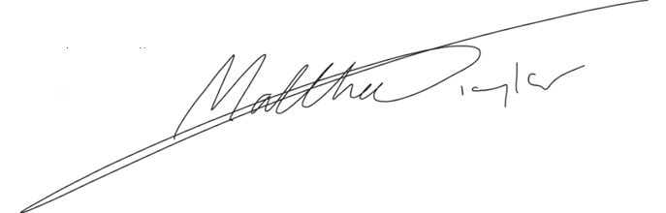
Position - Director

