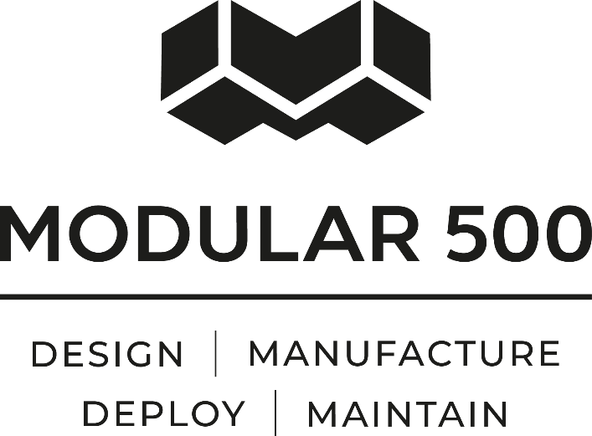
Occupational Health & Safety Strategy

Modular500 Ltd (The “Company”) believes that we should all go home from work free from illness and injury. We aim to manage Health and Safety in a proactive and professional manner, integrated into our culture, values and the way we do business. In order to protect our staff, sub-contractors and other stakeholders from injury or illness, we must treat Health and Safety as highly as we do our other core values and make it an integral part of the solution we provide to our clients.
Our key aims within this vision include
- The development and operation of a health and safety system – taking the Health and Safety policy and planning its integration throughout the company, organising how changes are implemented, measuring its performance against set standards then auditing and reviewing its performance.
- Ensuring there are sufficient resources within the company to deliver on this vision.
- Demonstrating the importance of good Health and Safety by top management – taking every opportunity to reinforce how important this is, whether it is visible behaviour, written communication or reinforced face-to-face in meetings.
- Ensuring that every individual within the company is committed to achieving clear Health and Safety objectives, and their responsibility is clearly known.
- Developing a culture of co-operative and shared ownership with employees and subcontractors consulted in planning, measuring and reviewing performance.
- Complying with legal and other requirements – welcoming regular reviews from external bodies to ensure compliance.
- Actively encouraging sub-contractors to be in alignment with our Health and Safety policy.
- Identifying and meeting Clients Health and Safety expectations
To view our accreditations please visit our website https://www.modular500.com

Signed - Matthew Taylor

Date - 12/03/2025
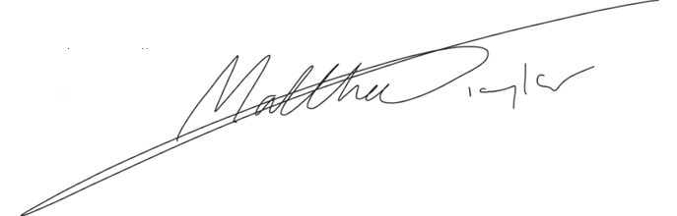
Position - Director

