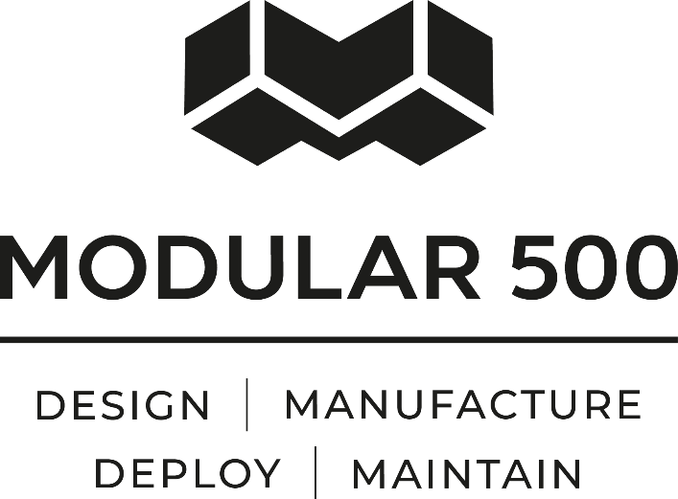

Quality Policy Statement

Modular500 Limited operates within processes and procedures that ensure the efficient quality management of its operations and supply of its products and services.

The company identifies and complies with all Health & Safety and Environment legislation relevant to its activities and endeavours to prevent harm or pollution from routine and non-routine activities and incidents as far as is reasonably practicable or required by law.

The Company is committed to the maintaining and improving its performance and where identified enacts improvements through the setting of objectives and targets.

To meet Company Objectives management sets and agrees objectives and provides resources for their completion.

Quality Management System

The Company has a Quality Management System (QMS) that incorporates BS EN ISO9001 for Quality and Health & Safety at Work act 1974 and subsequent legislation for Health & Safety.

The QMS is designed to monitor, give guidance and help resolve all matters relating to company performance and health and safety.

The Policy Statements and QMS are communicated and are applicable to all employees and sub-contractors and are effective during all phases and duration of the company’s operations. All employees and sub-contractors are made aware of their individual obligations towards quality and health and safety.

M500 Limited confirms its commitment to meet the requirements of this Policy Statement.

To view our accreditations please visit our website https://www.modular500.com

Signed - Matthew Taylor

Date - 12/03/2025
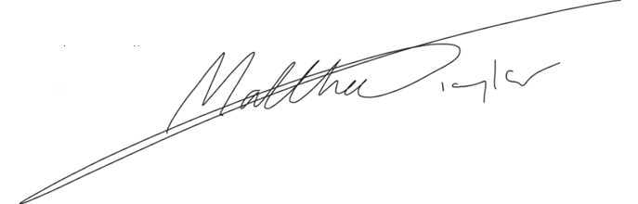
Position - Director

