Environmental Policy Statement

Modular500 Limited (the ‘Organisation’) recognises the importance of environmental protection and is committed to operating its business responsibly and in compliance with all environmental regulations, legislation and approved professional codes of practice specific to the design, manufacture, sale and erection of permanent, semi-permanent and temporary relocatable volumetric buildings. This is an on-going process of improvement to both goods and service provided and must include internal housekeeping.

It is the Organisation’s objective to operate with, and to maintain good relations with all regulatory bodies, and comply with all applicable legal requirements, and our Organisation’s declared policy on environmental issues to carry out all measures reasonably practicable to involve all staff assess the cost benefit of any decisions and facilitate the ability to continually improve environmental performance. We will publicise our efforts wherever possible, and:

- Assess and regularly re-assess the environmental effects of the Organisation’s equipment, building plant and facilities operations
- Adhere to all relevant regulations concerning waste and environmental well-being
- Ensure that all sub-contracted operations are in-line with this policy, and that they are aware of their respective responsibilities in the environment
- Train all employees in environmental issues, raise awareness and actively promote establishing a Clean and Healthy Environment
- Minimise the production of waste and material wastage
- Actively promote the use of recyclable and renewable consumable materials
- Minimise energy wastage by promoting the efficient use of energy, water and other resources
- Set out commitments in relation to the main areas where the Organisation has significant environmental impacts:

  - Consumable paper sourcing, through sustainable forestry and recycled qualities
  - Energy consumption - as detailed in our Energy Policy Statement
  - Greenhouse gases - carbon management and emissions in the supply chain
  - The purchase of contracted services
  - Reducing transport pollution

- Control of emissions from operations, and protect wildlife habitats wherever possible
- Minimise risk to the general public and employees from Organisation operations and activities

This policy is communicated to all employees, suppliers and sub-contractors and is made available to the public. All personnel understand their obligations under this policy statement and abide with the principals and contents of the Environmental Management System Manual. The Organisation constantly monitors and reviews its environmental

performance and this Environmental Policy Statement in order to ensure its continuing suitability and will implement appropriate improvements.

To view our accreditations please visit our website https://www.modular500.com

Signed - Matthew Taylor

Date - 12/03/2025
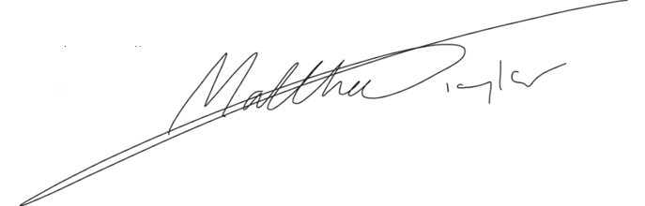
Position - Director

