The management of Modular500 is committed to providing all employees with a workplace that is free of hazards. To help with this the wearing of Personal Protective Equipment is mandatory whilst of the Chesterfield facility or Site. Personal Protective Equipment can include your Modular500 issued clothing, Safety boots, high visibility clothing / vests, Safety Glasses, Face Shield, Masks and Hearing Protection
The following is the minimum requirement of Personal Protective Equipment to be worn onsite or at the Chesterfield Production facility. Failure to wear the appropriate equipment may result in disciplinary action.

General Yard Area

- High Visibility Clothing or vest (Long Sleeved or Short Sleeved)
- Long Trousers
- Steel Toe cap shoes / boots or equivalent
- Shorts can be worn but only with Director Approval
*Please refer to RAMS and Tool Box talks for job specific Personal Protective Equipment PPE for working activities

Shop Floor

- High Visibility Clothing or vest (Long Sleeved or Short Sleeved)
- Long Trousers
- Steel Toe cap shoes / boots or equivalent
- Shorts can be worn but only with Director Approval

*Please refer to RAMS and Tool Box talks for job specific Personal Protective Equipment PPE for working activities
Site
On some occasions employees may be required to work on External sites. These sites may have different Personal Protective Equipment PPE requirements which must be adhered to. As standard please ensure you have the following PPE on your Person when attending site.
- High Visibility Clothing or vest (Long Sleeved or Short Sleeved)
- Long Trousers
- Steel Toe cap shoes / boots or equivalent
- Shorts can be worn but only with Director Approval
- Hard Hat
- Safety Gloves
- Safety Glasses
- RPE Mask
- Hearing Protection
Visitors
As a very minimum all Visitors must wear High Visibility clothing at all times when in the factory, for those visitors that don’t have protective footwear they must be supervised at all times.

To view our accreditations please visit our website https://www.modular500.com

Signed - Matthew Taylor

Date - 14/05/2025
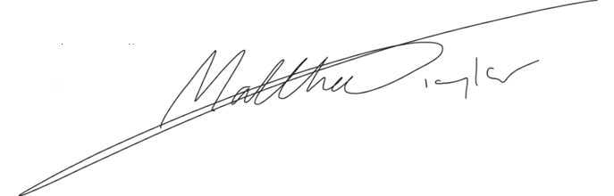
Position - Director

